**IFT 166 Introduction to Internet Networking**

**Lab 14**

**Understanding the importance of Default Gateways**

Co-authored by James Copsey

**After you complete each step, put a ‘√’ or ‘x’ in the completed box**

1. 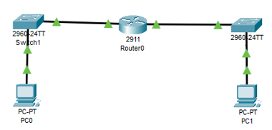Set up the following topology in packet tracer.



1. Configure PC0 as shown below

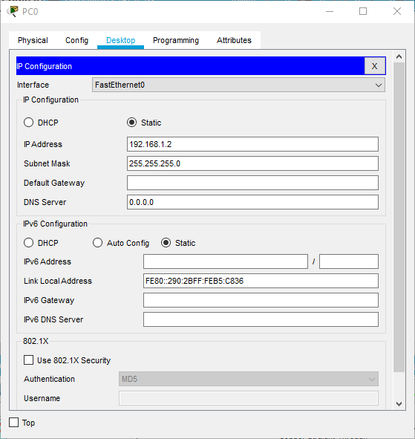



1. Repeat the previous step for PC1 giving it a different IP address so it is assigned to the 19.168.2.0



1. Now assign IP addresses to both GigabitEthernet0/0 interfaces on the router. You can the use GUI or the command line.



1. Attempt to ping PC1 from PC0.

What happened?

_____________________________________________________________________________  
  
_____________________________________________________________________________

Why didn’t the ping work?

_____________________________________________________________________________  
  
_____________________________________________________________________________

1. On PC0, enter in the default gateway as the IP address you set for GigabitEthernet0/0.

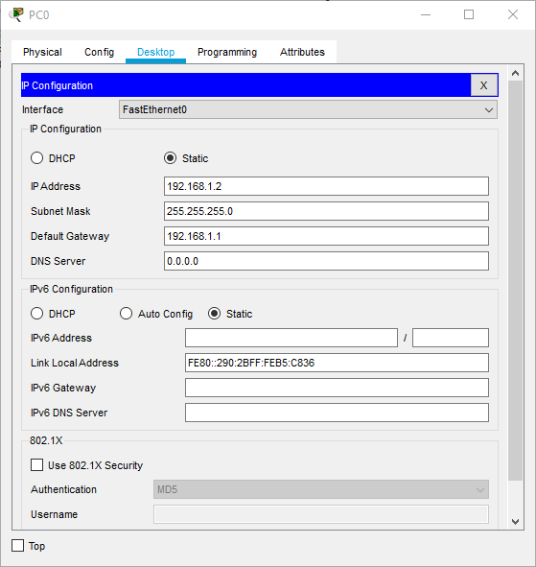



1. Repeat the same step for PC1 and GigabitEthernet0/1, that you did for PC0 in step 6.
2. Attempt to ping PC1 from PC0 again.

Did it work?   
  
It should be a “yes”

If not……..start troubleshooting 😊

1. Attach a screenshot of your successful ping below